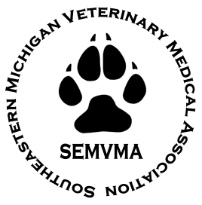
STUDENT DEBT REDUCATION APPLICATION FORM
- DEADLINE: October 17, 2026 -

Name of Member: ____________________________________________________________________________________
Last First Middle

Address: ______________________________________________________________________________________________
Street City State Zip Code

Email: ________________________________________ Telephone: _____________________________________

Graduation: __________________________________________________________________________________________
School Year

Member Employed By: ______________________________________________________________________________

Balance of Loan as of the date of this application: ________________________________________________

Loan Institution: _____________________________________________________________________________________
Name & Address & Account Number

- Graduated in the last 3 years (2024 – 2025 – 2026)
- Member of the SEMVMA (Membership will be verified through the SEMVMA Office)
- Have active student loan debt that can be verified from a lending institution
- Have not received the award in the past
- Work in one of the 9 SEMVMA counties (Wayne, Oakland, Macomb, Washtenaw, Monroe,
Livingston, Lapeer, Genesee, St. Clair)

Signature of Member: _______________________________________________________________________________
Date
My signature attests that I fulfill all requirements as listed above

Submit your application via email to SEMVMAsecretary@gmail.com or mail it to: SEMVMA, P.O. Box 4030, Southfield, MI 48037

